Yachting Australia Safety Cat 6 Stability Testing

Peter Halliday, owner of Smooth Operator at East Fremantle Yacht Club has undertaken stability testing of a SS22.

He has kindly agreed to share the results of his testing.

Please note – these results should be interpreted in conjunction with the YA document “Special Regulations for Racing Boats” which can be found on the Yachting Australia website - www.yachting.org.au as well as on the SS22 Association website.

The Testing:

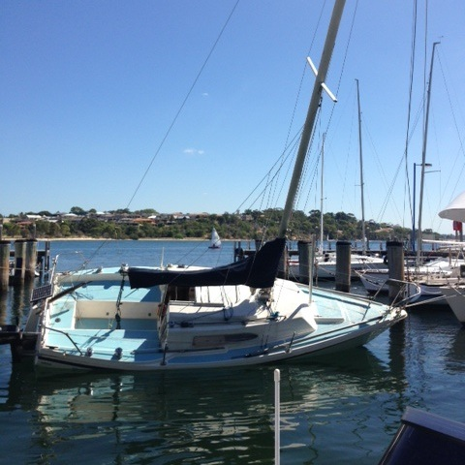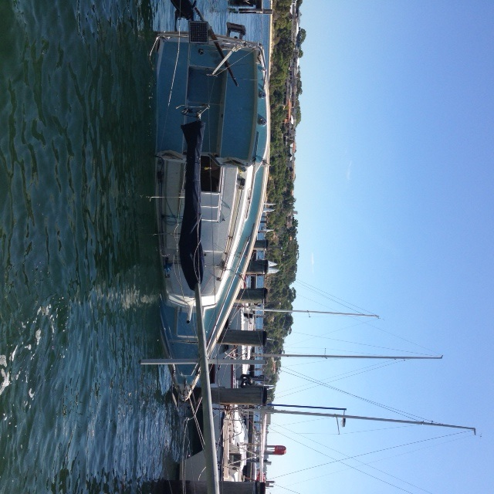

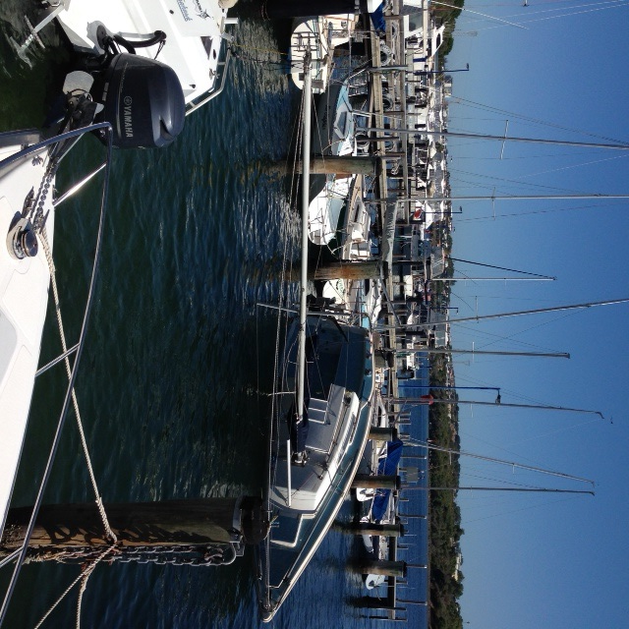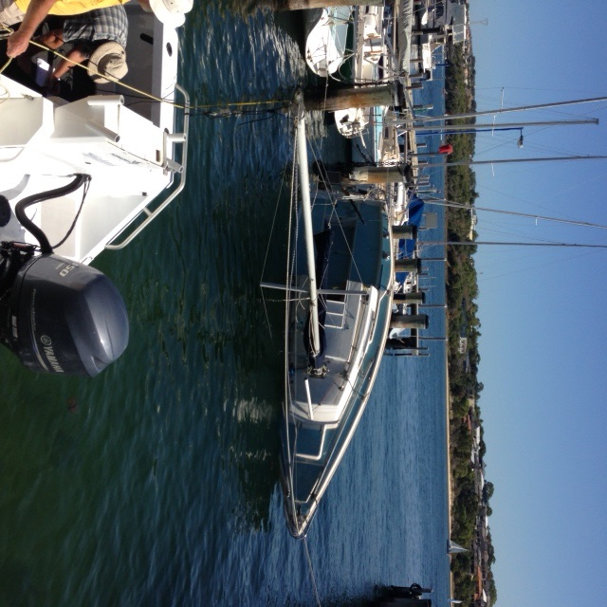

The Results:

